Sample Letter

The Honourable Firstname A. Lastname, P.C., M.P.
(Street Address)
(City, Town) (Postal Code)

(Date)

Dear Minister, Dear Mr./Mrs./Ms. Lastname,

[One line about yourself and where you live.] [I, We] am/are writing today as a member of your constituency to bring your attention to the plight of Eritrean and Sudanese refugees in Israel.

Forest Hill United Church (Bathurst/Eglinton) is sponsoring two Eritrean refugees from Israel: Asmat Gebreab Abraha, 33, and Million Haile Abreha, 29. Their sponsorship applications were approved by Immigration, Refugees, and Citizenship Canada (IRCC) last summer, and their files have been transferred to the Tel Aviv Visa Office for processing.

Recently, on November 19th, the Israeli caucus voted unanimously to expel African refugees to Rwanda against their will. Those who refuse to go are to be detained indefinitely in an Israeli jail. The United Nations High Commissioner for Refugees has raised “serious concerns” about this new development, noting that “Israel has legal obligations to protect refugees and other persons in need of international protection” (The Times of Israel, November 18, 2017). There are close to 40,000 African refugees in Israel, almost all of whom are from Eritrea and Sudan.

From what we understand, the Canadian Visa Office in Tel Aviv operates with very limited resources and the files can take a couple of years to be processed. We are deeply concerned this new aggressive Israeli policy will result in either the deportation or indefinite detainment of Asmat and Million, and dozens of other refugees, who are already in the sponsorship pipeline to Canada. Details are still murky, but we understand mass deportations may begin as early as March 2018.

We are requesting that the Canadian government a) add more resources to the Visa Office in Tel Aviv to expedite the cases of privately sponsored refugees whose applications have already been approved by IRCC; b) work with the State of Israel to guarantee the safety of applicants until they complete their sponsorship process; c) appeal to the State of Israel to put a stop to this new policy.

If it is possible to meet and discuss this matter further, please contact _____________________

Sincerely,

(Your Name)
(Street Address)
(Town, Province) (Postal Code)
(Phone Number if applicable)

Riding | Member of Parliament | Contact Information
Eglinton-Lawrence | The Honourable Marco Mendicino, M.P. | Constituency Office:  511 Lawrence Avenue West  Toronto, Ontario M6A 1A3  Telephone: 416-781-5583  Fax: 416-781-5586  Email: Marco.Mendicino@parl.gc.ca  WebSite: marcomendicinomp.ca
Toronto St. Paul’s | The Honourable Carolyn Bennett, P.C., M.P. | Constituency Office:  40 Holly Street, Suite 103  Toronto, Ontario M4S 3C3  Telephone: 416-952-3990  Fax: 416-952-3995  Email: carolyn.bennett@parl.gc.ca  WebSite: carolynbennett.ca
Davenport | The Honourable Julie Dzerowicz, M.P. | Constituency Office:  1202 Bloor Street West  Toronto, Ontario M6H 1N2  Telephone: 416-654-8048  Fax: 416-654-5083  Email: Julie.Dzerowicz@parl.gc.ca  WebSite: jdzerowicz.liberal.ca
York Centre | The Honourable Michael Levitt, M.P. | Constituency Office:  660 Wilson Avenue  Toronto, Ontario M3K 1E1  Telephone: 416-638-3700  Fax: 416-638-1407  Email: Michael.Levitt@parl.gc.ca  WebSite: mlevitt.liberal.ca
York South-Weston | The Honourable Ahmed Hussen, P.C., M.P.  [Minister of Immigration,  Refugees and Citizenship] | Constituency Office:  99D Ingram Drive  Toronto, Ontario M6M 2L7  Telephone: 416-656-2526  Fax: 416-656-9908  Email: Ahmed.Hussen@parl.gc.ca  WebSite: ahmedhussenmp.ca
Don Valley West | The Honourable The Reverend Robert Oliphant, M.P. | Constituency Office  1670 Bayview Avenue, Suite 310  Toronto, Ontario  M4G 3C2  Telephone: 416-467-7275  Fax: 416-467-8550  Email: Rob.Oliphant@parl.gc.ca  WebSite: roboliphantmp.ca

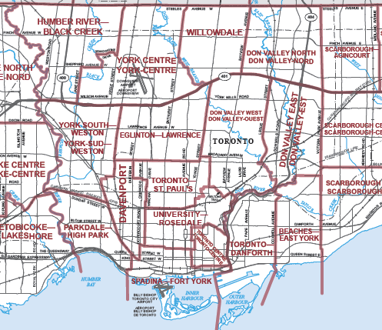

For map, please visit:
http://www.elections.ca/res/cir/maps2/mapprov.asp?map=Toronto&b=n&prov=35&lang=e

